Chapter 19, Problem 77.

Using PSpice, find the h parameters of the network in Fig.19.123. Take ω = 1 rad/s.

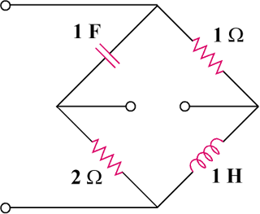

Figure 19.123
For Prob. 19.77.

